8218-Arsh Nadeem-Introduction to java 2-Jan 2025

1. Write a program to display values of enums using a constructor & getPrice() method (Example display house & their prices)

-> here we have to make an enum class ‘House’ and a main class ‘EnumExample’

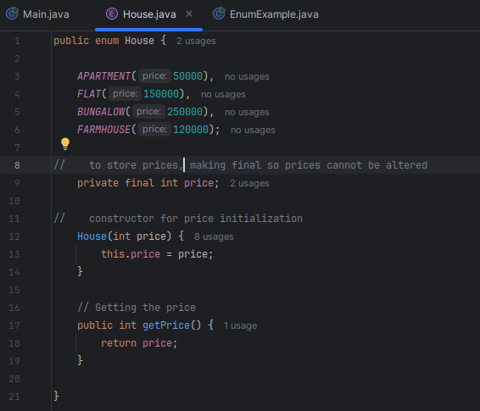

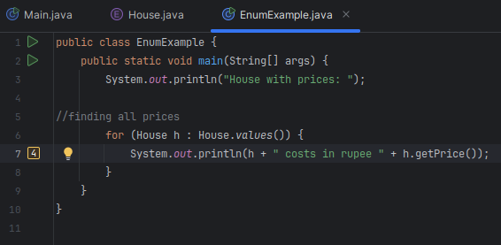

Output:
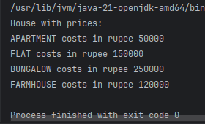

2. Create a User class with fields: firstname, lastname, age, phone number. Write a program which accepts values of user fields from commandline, create object and append that to a text file. After every user creation the program should prompt: "Do you want to continue creating users? (Type QUIT to exit)" and keep on accepting values and writing to file until user quits.

-> creating Userdetail class and and User class
-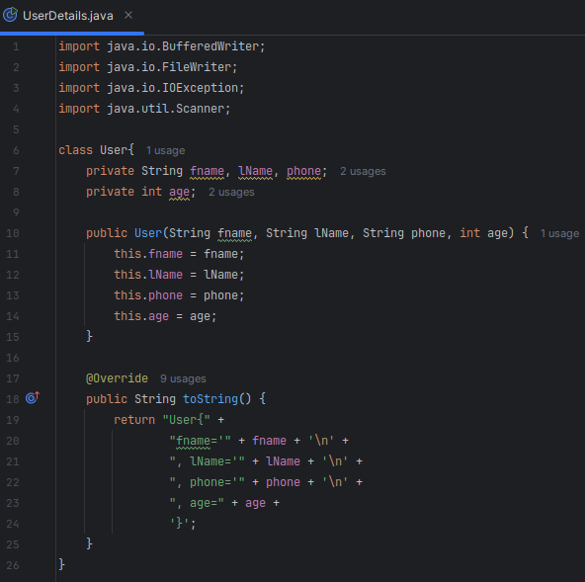

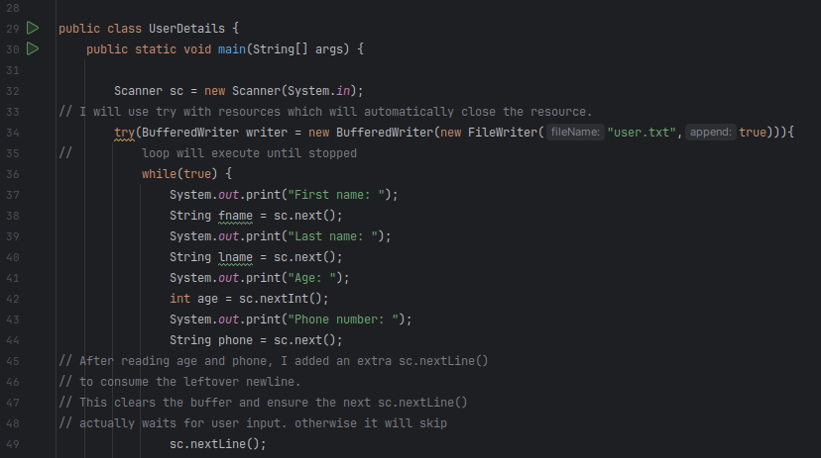
-> writing in file
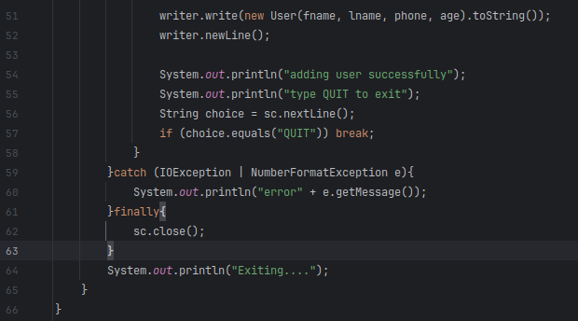

Output:
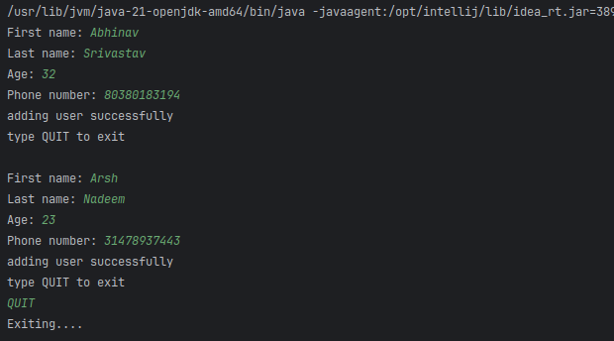
-> checking the file content. This file will be permanently saved.
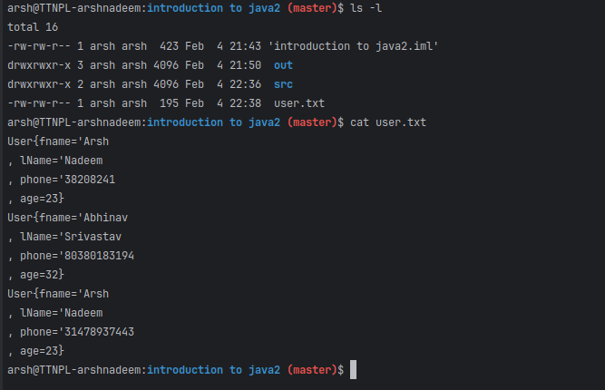

3. Write a program to count the number of occurrences of a word in a file. The file name and word should be supplied through commandline.
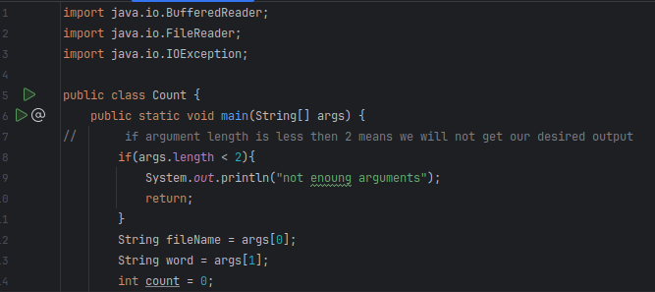
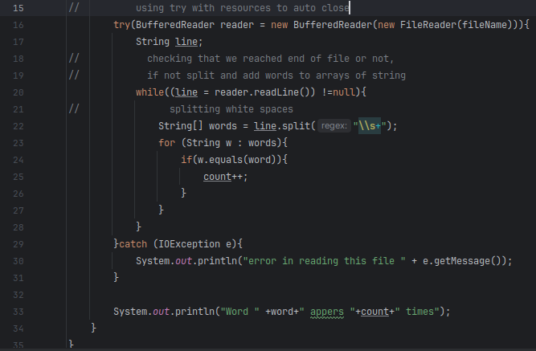

Output:
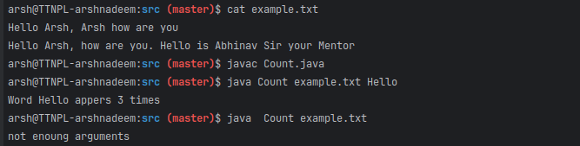

4. Write a program to show application of Factory Design Pattern.

->Directory structure:
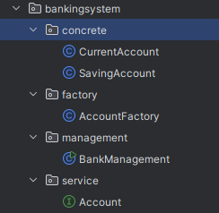

->interface : I will define common methods for all accounts.
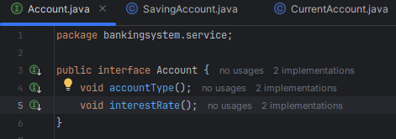

-> concrete includes the types of accounts i.e. concrete classes
* implementing all methods of interface ‘Account’
->Saving account details
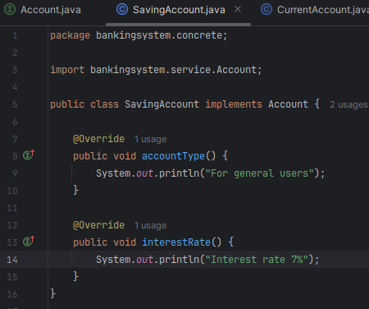

-> CurrentAccount details
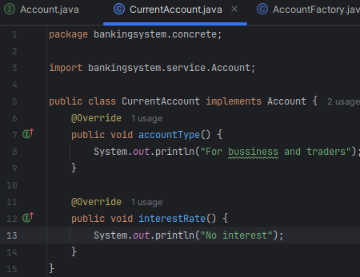

AccountFactory : It will return the correct object based on input.

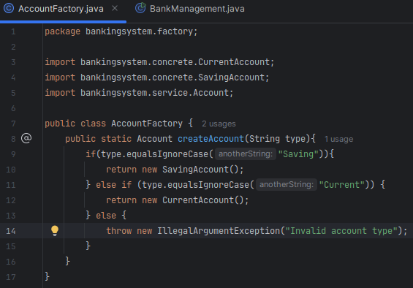

-> management i.e main class
-> assigning type of account to account based on the input
-> displaying the information i.e. account and rate

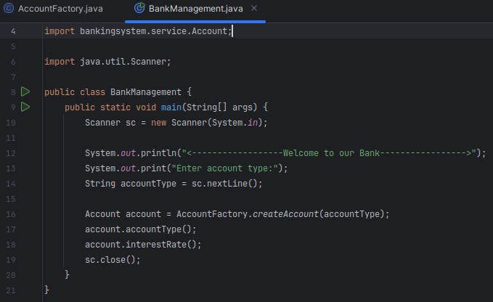

Output:
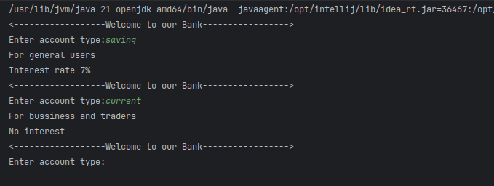

5.Write a program to show application of Singleton Design Pattern.

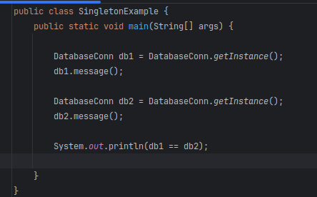
-> The static variable (instance) belongs to the class, not any specific object.By this, all objects share the same instance.
-> We call DatabaseConn.getInstance() without creating an object.This prevents multiple instances from being created.
-> Since only one instance exists, it avoids unnecessary memory usage
